# Additional Requirements

## Accessibility Evaluation

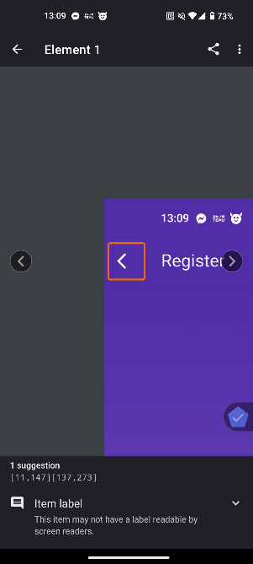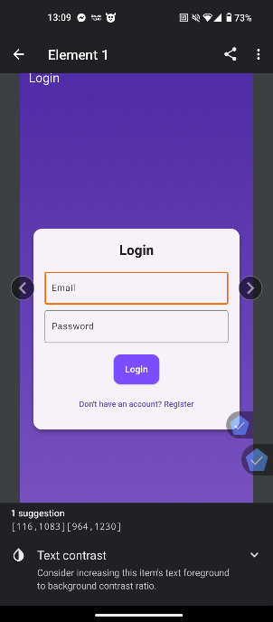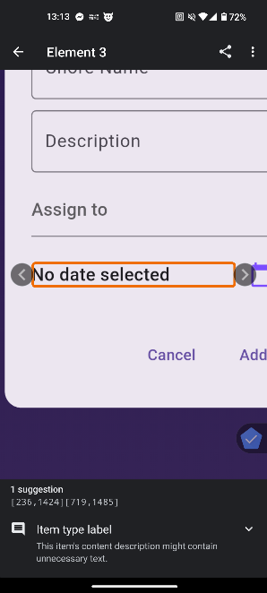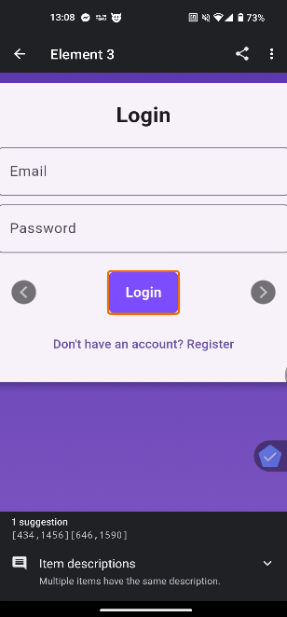

## Future Enhancements:

* Faster Image Gathering by not using Base64 Method
* Using A Private Database so that it does not rely on subscriptions or Firebase
* More Features/ Modules like Camera Management or Smart Devices Management

## Design & Prototyping

Below are the Links for the wireframes

Login Screen: <https://wireframe.cc/5Fyqnv>

Register Screen: <https://wireframe.cc/WGjy3M>

Home /NoGroup: <https://wireframe.cc/WfUuRB>

Create/Join Group: <https://wireframe.cc/monO5f>

Join Group Modal : <https://wireframe.cc/7Kjq6u>

Home Screen With Group : <https://wireframe.cc/1KpyyI>

Chore List: <https://wireframe.cc/8cv1KX>

Shopping List: <https://wireframe.cc/8dnsyj>

Fridge Image: <https://wireframe.cc/wu3pWT>

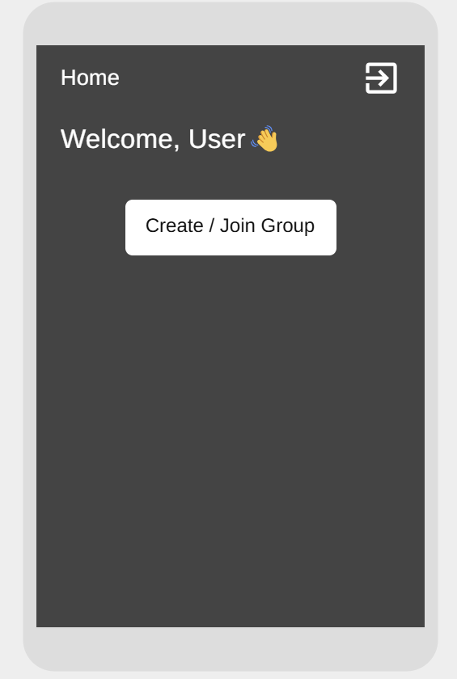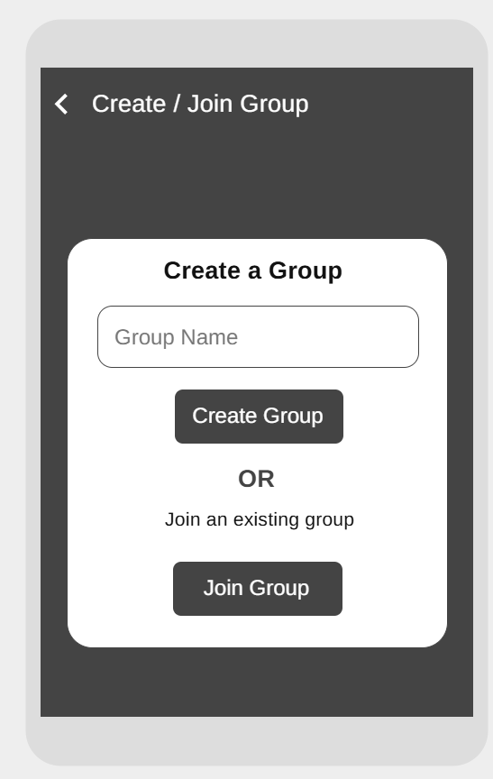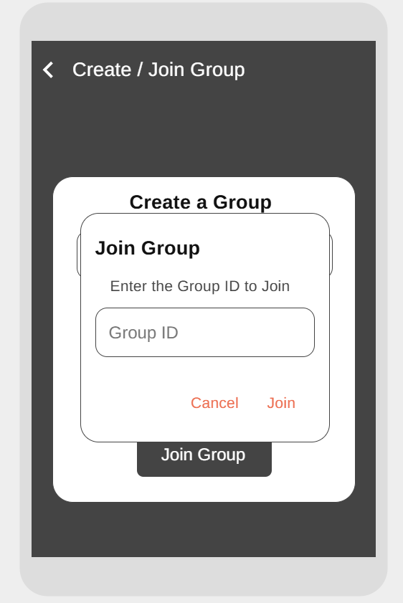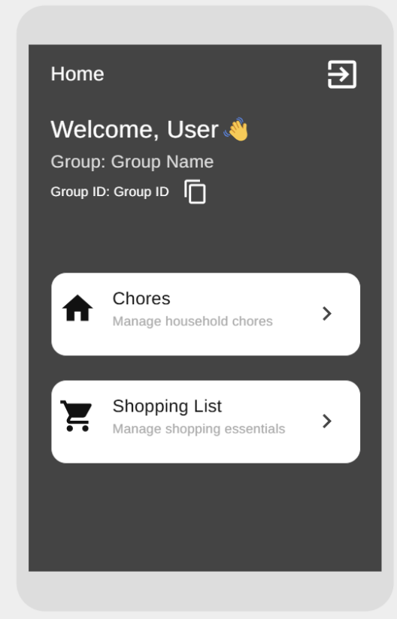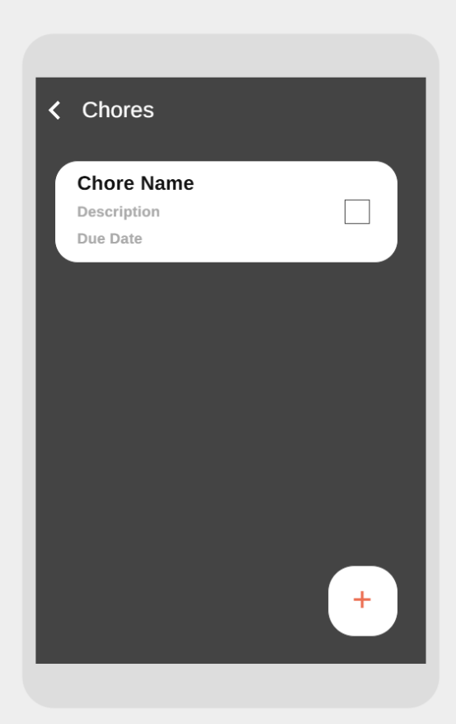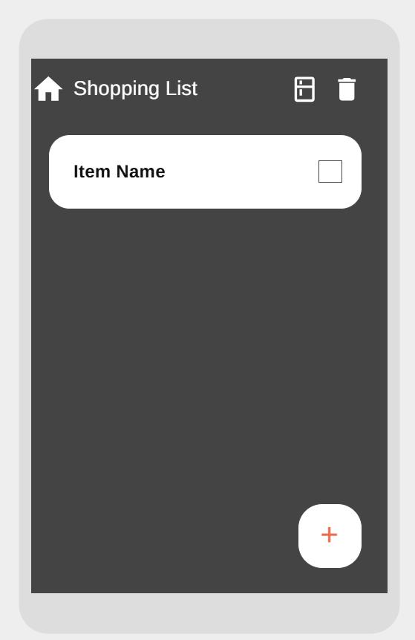

## Responsive Design

**Large Screen**

**Medium Screen**

**Small Screen**

## Performance Analysis

This is the Frame Analysis of a single frame in this specific frame there was a UI Jank, and a Raster Jank Detected which means it took the longest to build the UI

The Screenshot below shows the Rebuild Stats of the Selected frame which shows us how many times a component was rebuilt

This is another Profiling tool in the Flutter DevTools this is the Logging tool, this logs every transition that happens in the app and other types of event logs

## Analytics

A lot of analytics can be collected with Firebase these include

* User Demographics like location, gender and interests
* User Engagement like Active Users and Session Frequency
* Custom Events Like Adding an Item to the cart and what item it is
* Monetization Analytics like tracking in-app purchases
* Crash & Performance Analytics like tracking app crashes and errors

## GitHub Actions & Workflow Automation

GitHub Actions & Workflow is an automation platform that enables CI/CD. It allows task automation like deploying code, building and testing directly from repositories using workflows

### A screenshot of a computer program AI-generated content may be incorrect.GitHub Actions Code: